Singleton Heights Public School
Telephone: 6573 1363
Facsimile: 6573 1414
email:singletonh-p.school@det.nsw.edu.au
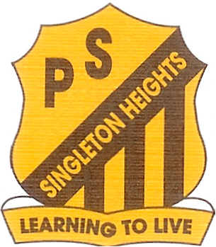

Principal: Mr Shaun Graham

Dorsman Drive,
Singleton Heights 2330

21st February, 2018

Dear Parents or Caregivers
Due to the success of the Waraya Homework Centre last year we will recommence these classes in 2018. Please be aware that the Homework Centre will continue to operate on a Monday, with the first session commencing on MONDAY 26th February, 2018 in the Kinder Alpacas (KA) classroom.
The centre will be under the tutorship of Kathryn Anderson, Karen Thompson, Julie Brooker and Jessica Allen. We have a group of dedicated teachers who are volunteering their time as well.
In addition to assistance with their homework, children will participate in reading, mathematics and cultural activities. Our primary aim is to cater for the individual academic needs of the students.
Children will be provided with a healthy afternoon snack.
Sessions conclude at 4.30pm.
It is your responsibility to arrange how your child will return home at 4.30pm.
The Homework Centre is primarily for students from Year 2 to Year 6.
Please return the permission note to the school office.
Attendance will be subject to students demonstrating behaviours in line with our school values.

Yours sincerely,
Kathryn Anderson Shaun Graham
Co-ordinator Principal
_________________________________________________________________________________
PERMISSION NOTE
WARAYA HOMEWORK CENTRE 2018

I give permission for my daughter/ son to attend the homework class after school.

I understand that I am responsible for organizing how they will get home after these classes.

Child’s name _____________________________________ Class _____________

I have organized for _______________________ to walk/ride/ I will pick them up.

Is there any food your child is NOT to eat: YES/NO
If so, what __________________________________________________________

Signed ______________________________ Date_________________

