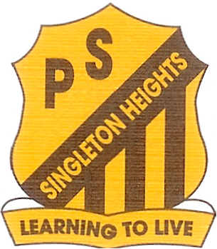
Singleton Heights Public School

Dorsman Drive Telephone: 65731363
Singleton Heights 2330 Facsimile: 65731414
Email: singletonh-p.school@det.nsw.edu.au

Principal: Shaun Graham 21st February 2018

Dear families,
We are very excited that we can offer our Indigenous students the opportunity to participate in Aboriginal Cultural program this year. This program will provide children with important cultural links, information and skills to use throughout their education and life.
The groups will be supervised by Mrs Anderson and Miss Allan, with assistance from local Aboriginal community member, Chris Feeney. Student will have the opportunity to participate in the following groups depending on their age:
- 3-6 Boys Cultural Group (Even week Fridays 12:00pm-1:00pm)
- Primary Cultural Dance Group (Even week Fridays 2:00pm-3:00pm)
- 3-6 Girls Cultural Group (Odd week Fridays 12:00pm-1:00pm)
- Infants Cultural Dance Group (Odd week Fridays 2:00pm-3:00pm)
Children must return this permission note and will be expected to be on their best behaviour at all times, with respect, responsibility and excellence, in order to be an active member of these groups.
Yours Sincerely,
Kathryn Anderson & Jessica Allan Shaun Graham
Class Teachers and Aboriginal Cultural Group Teachers Principal
_______________________________________________________________________________
PERMISSION TO JOIN SINGLETON HEIGHTS CULTURAL GROUPS 2018

I give permission for my child ____________________ in class _________ to participate in the following Aboriginal Cultural groups (Please tick)
- 3-6 Boys Cultural Group (Even week Friday’s 12:00pm-1:00pm)
- Primary Cultural Dance Group (Even week Fridays 2:00pm-3:00pm)
- 3-6 Girls Cultural Group (Odd week Fridays 12:00pm-1:00pm)
- Infants Cultural Dance Group (Odd week Fridays 2:00pm-3:00pm)
Please note any changes to your child’s current medical form: _________________________________

Signed ______________________________Date _______

